API Documentation: User Redirection and Token Generation

API Overview
This API facilitates redirection from a specific panel to the main ERP system based on user authentication. The API accepts two parameters: email and panel. It authenticates the user by validating the provided email and issues a token upon successful validation. The panel parameter is used to determine the redirection link and manage the behavior of the "Back" button in the ERP interface.
API Endpoint : https://api.kipsqpg.com/api/login/directlogin
Parameter | Type | Description | Required
email | String | The email associated with the user account in the main panel (used for login verification). | Yes
panel | Int | The panel number for redirection purposes: 1 for Panel 1, 2 for Panel 2. If not provided, no back button will be shown in the ERP. | Yes

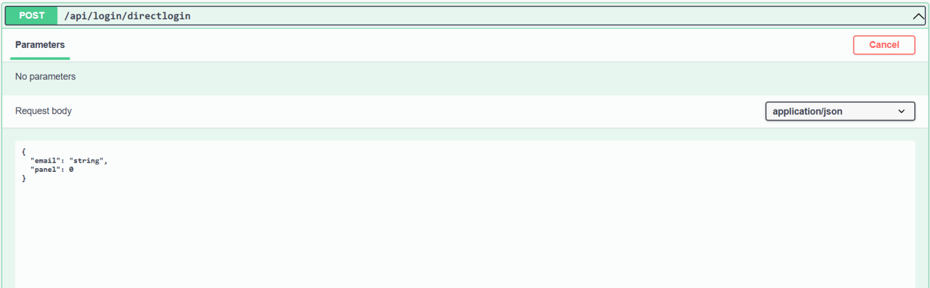

Functionality Flow
- Email Verification:
  - The API first verifies if the provided email matches an existing user email in the main ERP system.
  - If the email is valid, the user is logged into the main panel, and further processing occurs.
  - If the email is invalid, the API returns an error response indicating the user is invalid.

- Panel Parameter:
  - If the panel parameter is provided:
    - 1: Redirect to Panel 1. The back button will allow navigation to Panel 1.
    - 2: Redirect to Panel 2. The back button will allow navigation to Panel 2.
  - If the panel parameter is not provided, no back button will appear on the user interface in Kips ERP.
- Token Creation:
  - Once the email is validated, a secure token is generated using the email as part of the payload. This token is essential for secure redirection and access to the requested panel.
- Response:
  - If the user is valid, the API responds with query string containing:
    - A JWT token for secure redirection.
    - The provided panel in the query string to control redirection behavior.
  - If the user is invalid, the API returns an error message indicating "Invalid user."
Response for Invalid User:
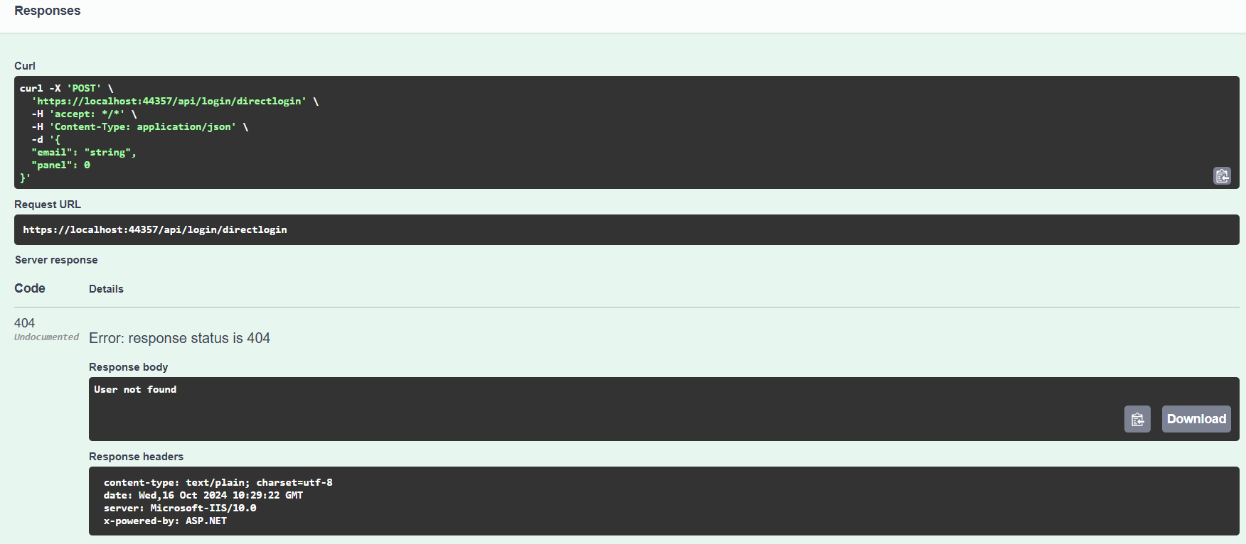
Response for Valid User:
